A000-US-AL-Tuscumbia-Colbert County-Mace-Slate-Mississippian-800 CE 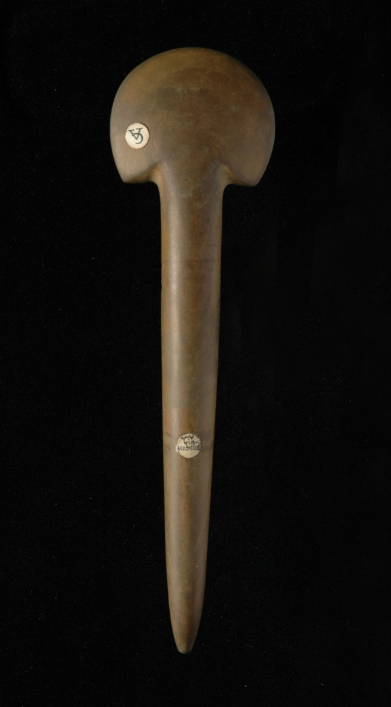

**Case no.:**

**Accession Number:**

**Formal Label:**

**Display Description:**

Rounded Head with a tapered barrel shaft, tapering to a point.

**LC Classification:**

**Date or Time Horizon:**

**Geographical Area:**

**Map:**

**GPS coordinates:**

**Cultural Affiliation:**

**Media:**

In a Medium Brown/Yellow colored slate, with an excellent patina.

**Dimensions:**

Length: 7 & 7/8" or approximately 2OOmm.

**Weight:**

**Condition:**

**Provenance:**

EX: William L. Watters Collection - Godfrey Illinois

EX: Charles L. (Chuck) Adam Collection - Crestwood, Missouri

Pictured in Who's Who in Indian Relics #2, page 19.

Acquired by Adam from the Estate of Watters in 1965.

EX:  Floyd Ritter Collection - Collinsville, Illinois

Acquired by Ritter from Adam in a lot of 3 spuds as pictured.

EX:  Roy Pohler Collection - Lake Charles, Louisiana

**Discussion:**

**The most insightful exposition of this class of artifact that has come to be known as “spud” is found in Moorehead, 1: Chapter XXII. It is rarely of a size or shape that would call it to be utilitarian so the use of this artifact has been labelled “ceremonial”: Moorehead 1819 1:429-430:**

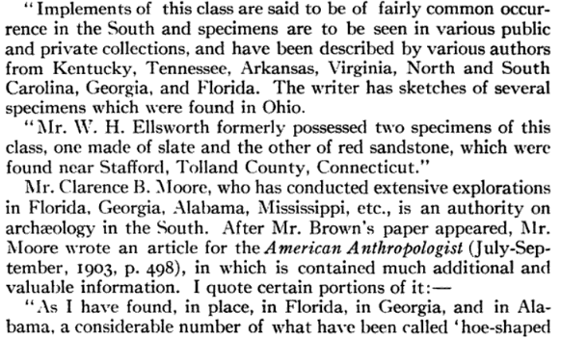 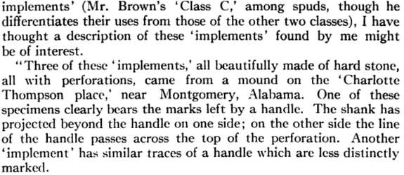

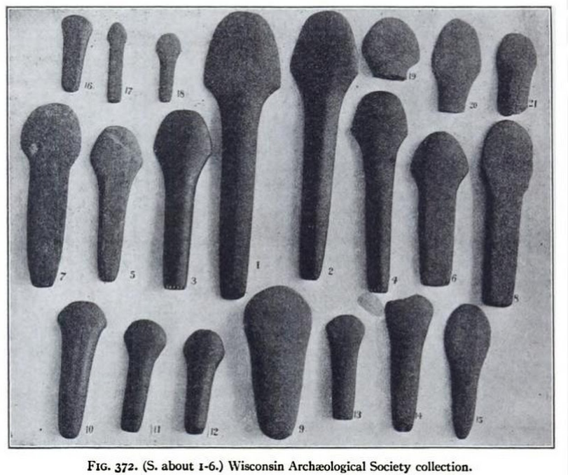 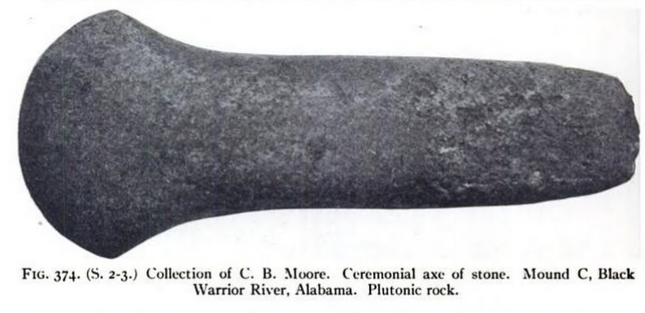 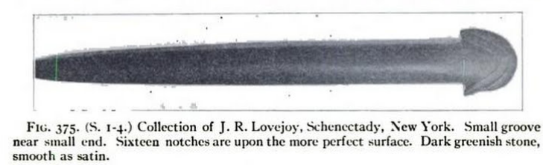

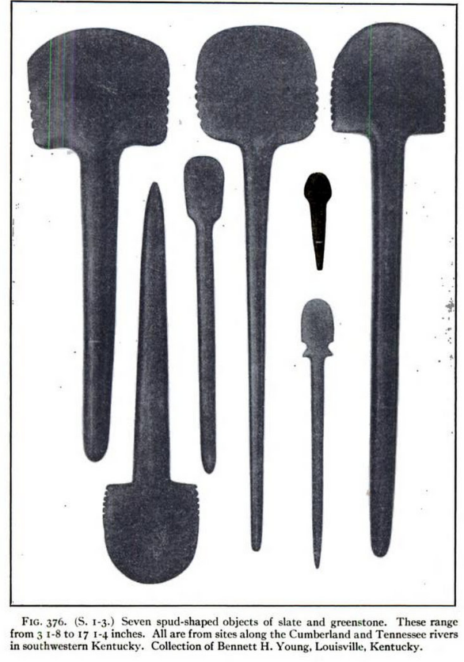

**References:**

Moorehead,Warren King. 1910, The stone age in North America; an archæological encyclopedia of the implements, ornaments, weapons, utensils, etc., of the prehistoric tribes of North America, with more than three hundred full-page plates and four hundred figures illustrating over four thousand different objects, by Warren K. Moorehead ...Boston, New York, Houghton Mifflin Company,